Fog and Scan Post Processing effect

Here are some recommended settings for both effects:

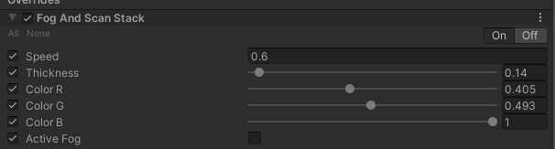

Figure This is recommended the setting for scan effects.

* The output of the above setting

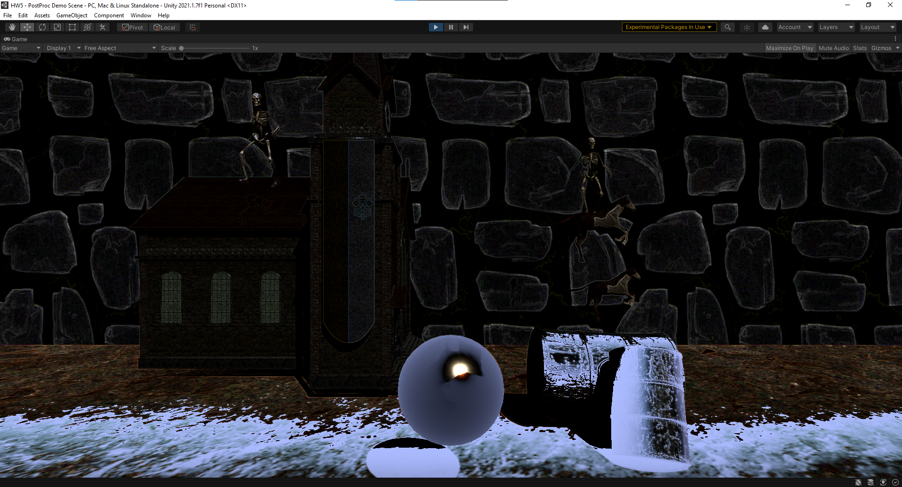

Figure scanning forward

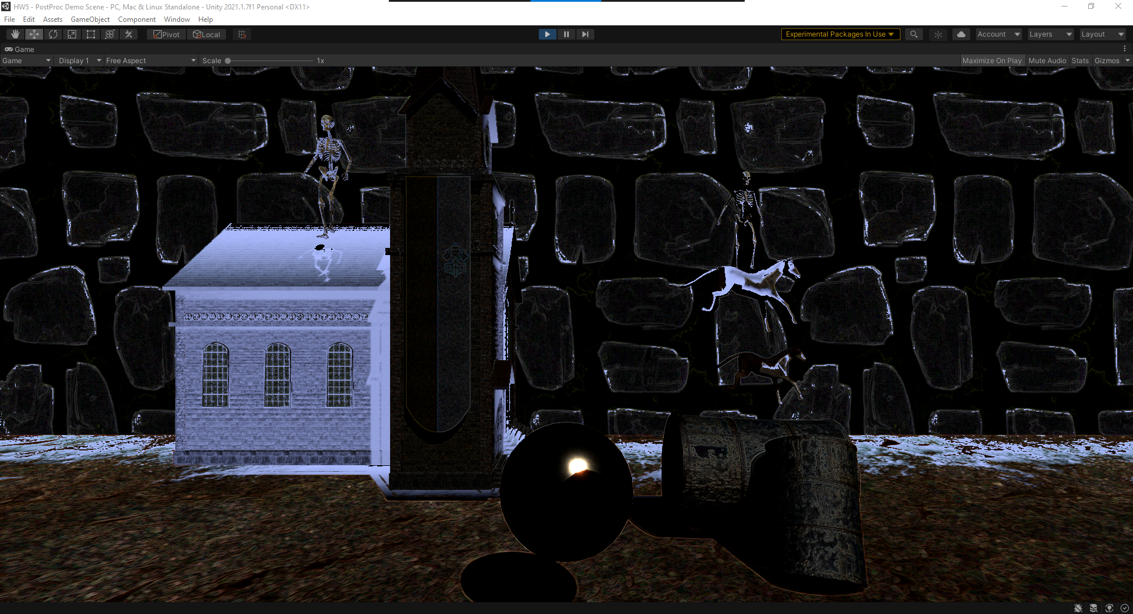

Figure Scanning Coming back

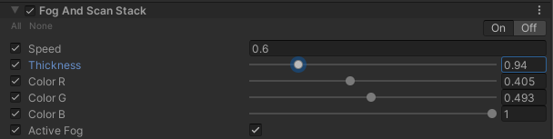

Figure This is for the Fog effects

* The output for the fog effects

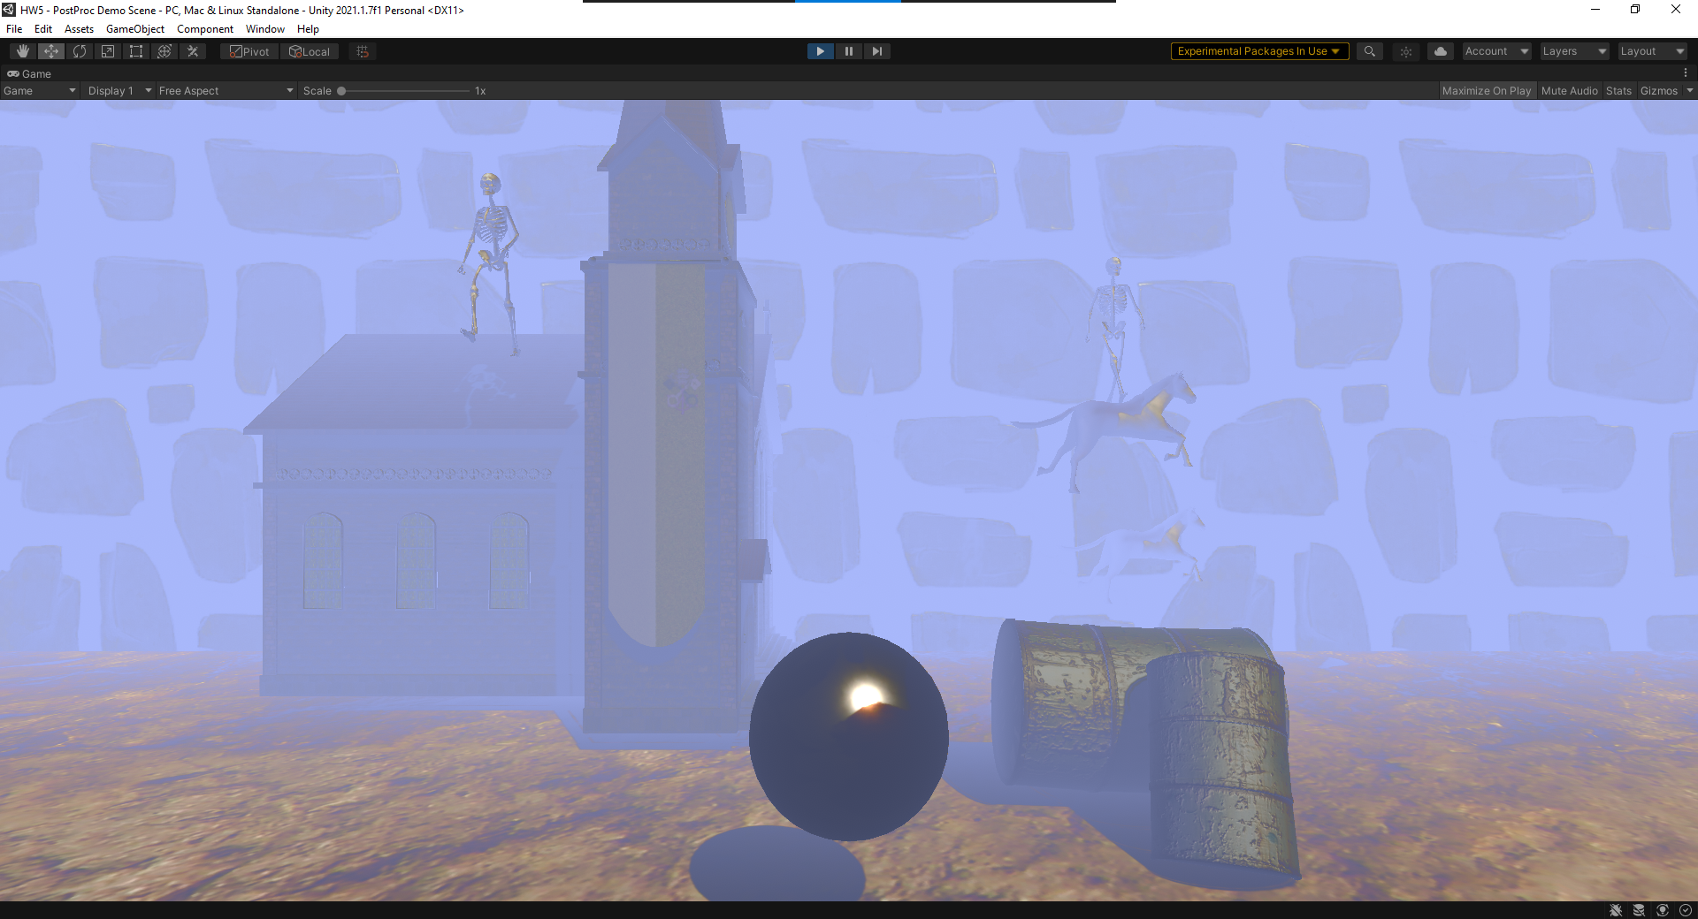

Figure exact setting as above

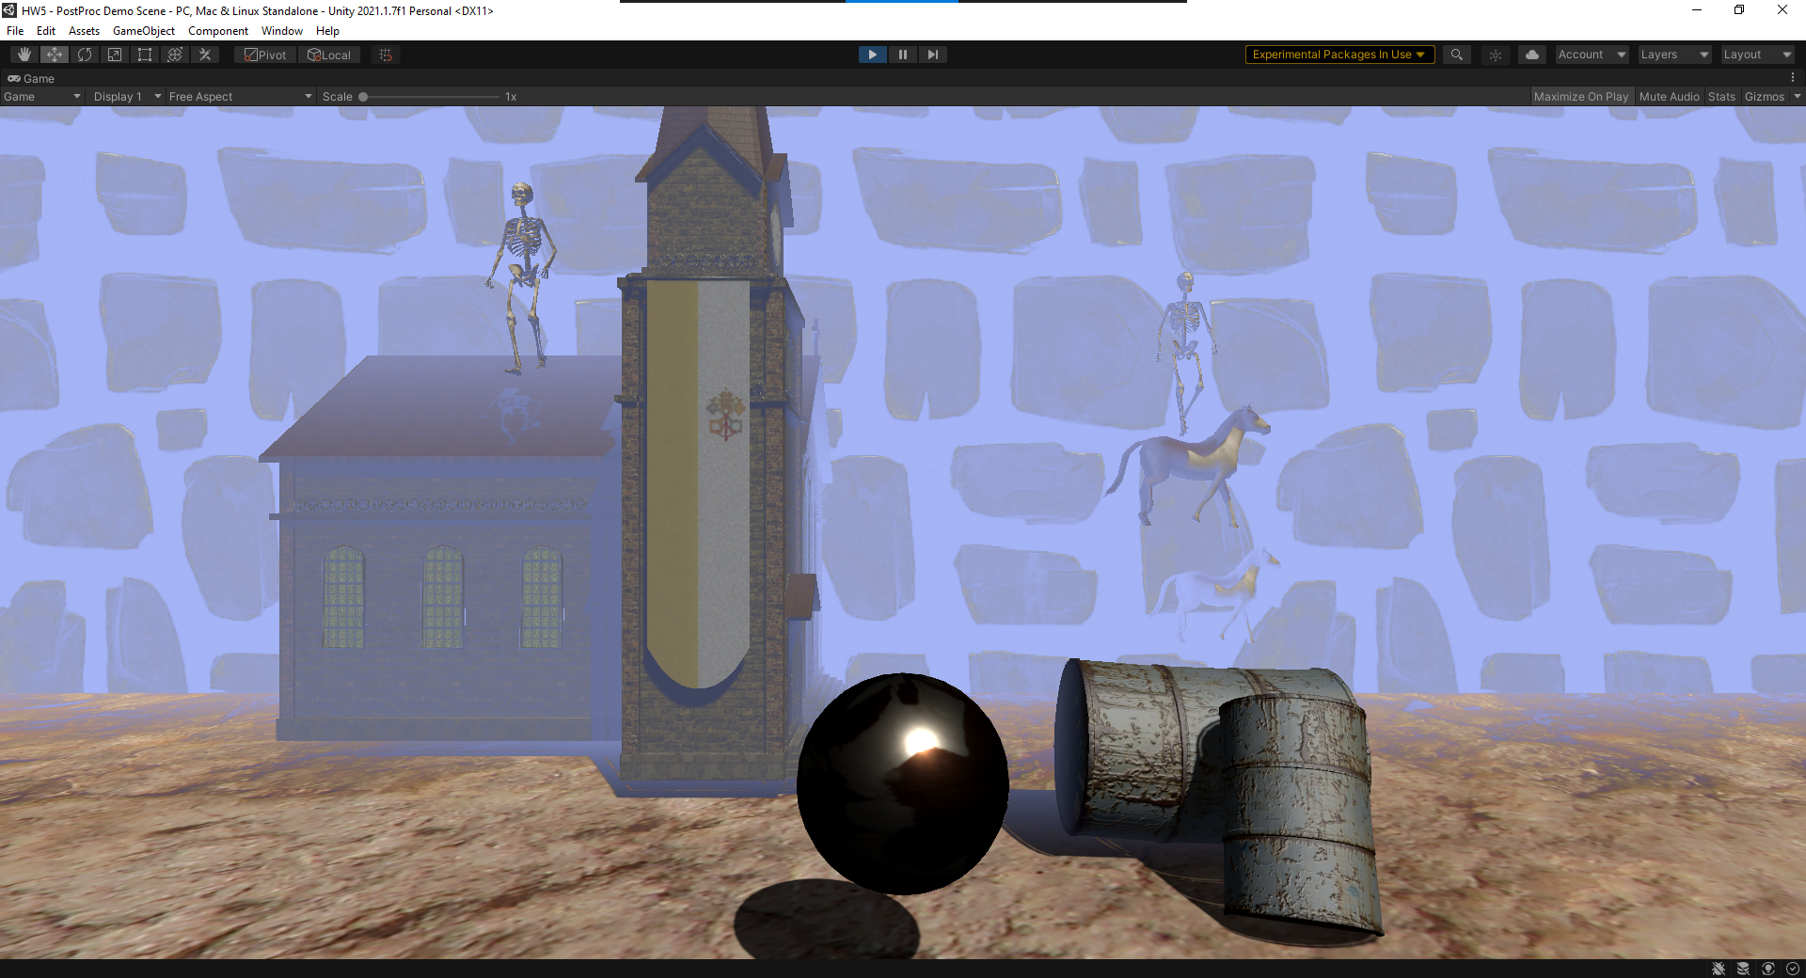

Figure less thick fog